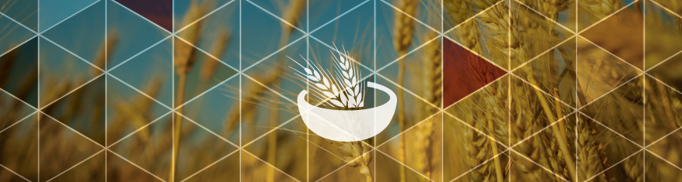
2022-23 MnDRIVE Global Food Ventures (GFV)

Graduate Student Development Award – Application

Please complete the application form below and submit electronically via Google Forms by 5:00 pm on February 23, 2022. Submit your complete application in a single PDF file to the application submission form: https://forms.gle/11uTAkTS3sfiJU2a8.

The application must include all components:
- Application cover page, applicant and academic information.
- Personal statement, describing how this award will advance your career aspirations (1 page maximum).
- Research statement, describing your research and its relevance to this MnDRIVE program (1 page maximum).
- Curriculum vitae, including previous education, honors/awards, research experience, publications, patents, and conference abstract titles (2 page maximum).
- Recommendation letter from the major advisor supporting your participation in this program and your rationale for participating.
- Unofficial copy of current UMN transcript.

APPLICANT INFORMATION
Full Name:
Email Address:

ACADEMIC INFORMATION
College:
Degree Program:
Degree Type: | ☐ PhD | ☐ Masters (Plan A only) | ☐ Professional
Thesis Advisor:
PRIOR ACADEMIC TRAINING (if applicable)
Institution | Dates | Degree | Major | GPA
Personal statement, describe how this award will advance your career aspirations (1 page maximum).

Research statement, describe your research and its relevance to this MnDRIVE program (1 page maximum).

Attach your curriculum vitae (CV) here.

Attach your recommendation letter here.

Attach your unofficial transcript here.

